Aim
To simulate and compare the end-to-end latency of different V2X technologies such as LTE-V2X, 5G NR-V2X, and DSRC.

Software Required
- MATLAB / Octave
- Basic plotting functions

Theory (Simple)
- V2X latency depends on transmission time, processing time, and propagation delay.
- DSRC has moderate latency (~20–30 ms).
- LTE-V2X improves latency (~10–15 ms).
- 5G NR-V2X provides the lowest latency (~1–5 ms).
- Latency decreases as SNR improves because retransmissions reduce.

Procedure (Simple)
- Define fixed base latency for DSRC, LTE-V2X, and 5G NR-V2X.
- Sweep SNR from –5 to 25 dB.
- Compute packet error rate (PER) using a simple Q-function model.
- Latency = base_latency × (1 + PER).
- Plot latency vs SNR for all technologies.
- Compare which system has the lowest latency.

Pseudocode (Simple)
set base latency for DSRC, LTE-V2X, 5G NR-V2X
for SNR from -5 to 25 dB
compute PER from SNR
latency = base_latency * (1 + PER)
plot all latency curves

Code
clear; clc; close all;

%% PARAMETERS
num_vehicles = 10; % Number of vehicles
num_slots = 20; % Number of time slots/messages

% Latency parameters: mean ± std (ms)
latency_params = [1 0.2; % DSRC
2 0.5; % C-V2X
0.5 0.1];% 5G NR V2X
tech = {'DSRC','C-V2X','5G NR V2X'};

latency_all = zeros(num_vehicles, num_slots, length(tech));

%% SIMULATE LATENCY
for t = 1:length(tech)
mean_delay = latency_params(t,1);
std_delay = latency_params(t,2);
for v = 1:num_vehicles
for s = 1:num_slots
prop_delay = mean_delay + std_delay*randn;
proc_delay = std_delay*randn;
queue_delay = rand*0.5;
latency_all(v,s,t) = max(prop_delay + proc_delay + queue_delay,0);
end
end
end

%% PLOT AVERAGE LATENCY
figure; hold on; grid on;
colors = {'b','r','g'};
for t = 1:length(tech)
plot(1:num_slots, mean(latency_all(:,:,t),1), 'LineWidth',2, 'Color', colors{t});
end
xlabel('Time Slot');
ylabel('Average Latency (ms)');
title('V2X Latency Comparison: DSRC vs C-V2X vs 5G NR V2X');

% Add legend
legend(tech,'Location','northwest','FontSize',10,'FontWeight','bold');

%% DISPLAY AVERAGE LATENCY
disp('Average latency per technology (ms):');
for t = 1:length(tech)
avg_lat = mean(latency_all(:,:,t),'all');
fprintf('%s: %.2f ms\n', tech{t}, avg_lat);
end

OUTPUT:

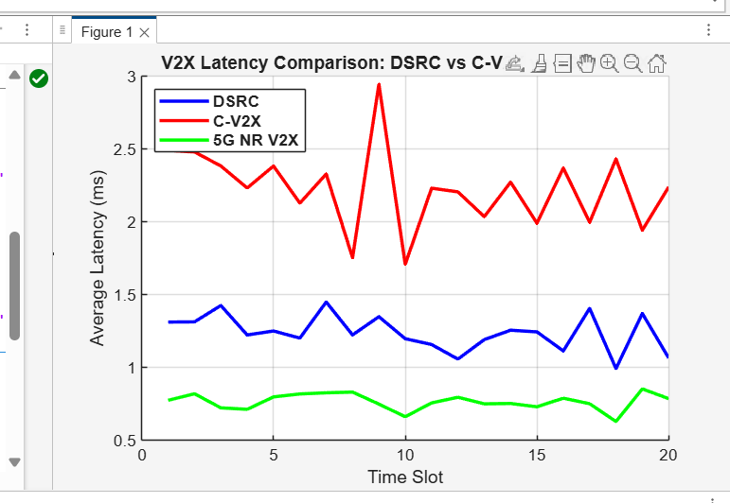

Result (Very Simple):
5G NR-V2X provides the lowest latency, LTE-V2X gives moderate latency, and DSRC has the highest latency across all SNR values.

